
Communication

Date | 3 July 2026
Team ID | xxx
Project Name | Smart Lender
Maximum Marks | 1 Mark

Communication Plan:
Effective communication is essential for a successful project demonstration. This document outlines the communication strategy used within the team and with stakeholders throughout the project lifecycle, including how updates, issues, and feedback were managed.
S.No | Challenge Faced | Resolution / Action Taken
1 | Difficulty integrating the trained XGBoost model with the Flask web application. | Verified feature order, retrained the model, and successfully integrated the saved model into the Flask application.
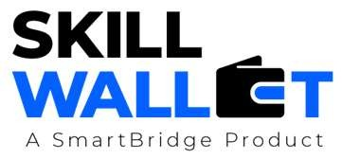
S.No | Communication Type | Frequency | Channel / Tool | Participants | Purpose
1 | Team Standup | Daily | WhatsApp, Google Meet | Team Members | Discuss daily tasks, assign work, and track project progress.
2 | Progress Update | Weekly | Google Meet | Team Members | Review completed work, discuss upcoming tasks, and receive guidance.
3 | Issue / Bug Discussion | As Needed | WhatsApp, VS Code Live Share | Team Members | Resolve coding issues, Flask errors, model prediction issues, and integration problems.
4 | Stakeholder Review | Bi-Weekly | Google Meet | Team Members | Present project milestones, gather feedback, and improve the application.
5 | Final Demo Rehearsal | Once | Google Meet | Entire Team | Practice the final project demonstration and presentation.
6 | Documentation Review | Once | Google Docs | Team Members | Review project documentation, README, and final report before submission.

Communication Challenges & Resolutions:
2 | Email notification and database integration issues. | Configured Gmail App Password using a .env file and implemented SQLite database storage for user application details.
3 | UI improvements and prediction workflow issues. | Redesigned the user interface, improved form validation, tested multiple prediction scenarios, and fixed application bugs before deployment.

